Tutorial to setup

SITL Gazebo for Arducopter  
on Windows

**Version 0.8**

**Aurélien ROY**

**01/09/2015**

Content

I. Goal 2

II. Installation requirements 2

III. Beforehand downloads 2

IV. Acknowledgements 3

V. Limitations 3

VI. Setting up the Virtual Machine 4

1. Configuration of VMWare 4

2. 1st launch of Ubuntu 8

VII. Setting up the simulation 16

1. Installation of Ardupilot 16

2. Start the normal SITL 16

3. Installation of ROS 17

VIII. Launch a Gazebo simulation 18

IX. Install a Joystick 20

## Goal

The first part of this tutorial is intended to Windows users. It is a walktrough the setup of an Ubuntu virtual machine on VMWare, the setup of a shared folder that contains the Ardupilot project, so it is accessible from both Windows and Ubuntu, and the initial configuration of Ubuntu.

The second part covers the download and installation of Ardupilot’s SITL environment, and of ROS (Robot Operating System) that contains the Gazebo simulator. And finally it will guide you through the launch of a Gazebo simulation.

## Installation requirements

You will need:

* A good internet connection
* At least 40 Gb of free space on your hard drive
* A powerful computer (at least 6 Gb of RAM)
* 2 hours before you…

It is also possible to setup the Gazebo SITL on a less powerful computer if you install Linux Ubuntu directly (dual boot, no emulation).

## Beforehand downloads

**VMWare, version 12.0** (~60 Mo)

<https://my.vmware.com/web/vmware/free#desktop_end_user_computing/vmware_workstation_player/12_0>

For a 32 bits system, use the previous version:

<https://my.vmware.com/web/vmware/free#desktop_end_user_computing/vmware_player/6_0>

**Ubuntu, version 14.04.3** (~ 1 Go)

(similar to the 14.04.2 advised by ArduCopter)

64 bits version:

<http://releases.ubuntu.com/14.04/ubuntu-14.04.3-desktop-amd64.iso>

32 bits version:

<http://releases.ubuntu.com/14.04/ubuntu-14.04.3-desktop-i386.iso>

## Acknowledgements

Instructions and scripts have been inspired, or come partially from, the following sources:

* <http://dev.ardupilot.com/wiki/simulation-2/sitl-simulator-software-in-the-loop/setting-up-sitl-on-windows/>
* <http://dev.ardupilot.com/wiki/using-rosgazebo-simulator-with-sitl/>
* <https://pixhawk.org/dev/ros/sitl>
* *SITL_Manual_Setup_v3.1.doc*, available on <http://www.rcgroups.com/forums/showthread.php?t=2190616>

Many thanks to Alex Buyval for creating the initial Arducopter simulation on Gazebo, to the PX4 team for all their work on ROS/Gazebo, to Randy Mackay and the team from RC group for their VMWare instructions, and finally to the whole Ardupilot community !

## Limitations

A few directory paths had to be hard coded in the shell scripts that come along this tutorial (at the beginning of *step_3_install_arducopter.sh* and *step_5_create_ros_workspace.sh*).

The installation as described by the tutorial works for a single instance of the Ardupilot project, because it stores the path to Ardupilot project in the PATH environment variable.

## Setting up the Virtual Machine

These instructions are for Windows users.

It will setup a full Linux virtual machine, with graphical interface (contrarily to the basic Vagrant / VirtualBox emulation).

### Configuration of VMWare

#### Configuration summary

Summary of the configuration of the virtual machine:

|  |  |  |
| --- | --- | --- |
| **Page / Parameter** | | **Value** |
| Install from | | |
|  | Disc image | ubuntu-14.04.3-desktop-amd64.iso |
| Personalize Linux | | |
|  | Full name | apm |
|  | User name | apm |
|  | Password | apm |
| Name VM | | |
|  | Virtual machine name | SITL |
|  | Location | c:/px4/Virtual Machines/SITL |
| Disk Capacity | | |
|  | Disk capacity | 30.0 Gb |
|  |  | Split virtual disk into multiple files |
| Customize hardware | | |
|  | Memory | 3072 Mb |
|  | Processors | 4 |
|  | Network adapter | NAT |

|  |
| --- |
| *Note :*  The user name and password have been chosen for an easy use of the SITL. |

|  |
| --- |
| *Note :*  In my case I preferred to place all software / source codes relevant to Arducopter in the c:/px4 directory. But you can place it anywhere you wish, just change the paths in the rest of the document. |

#### Steps

In VMWare, click on « Create a New Virtual Machine »:

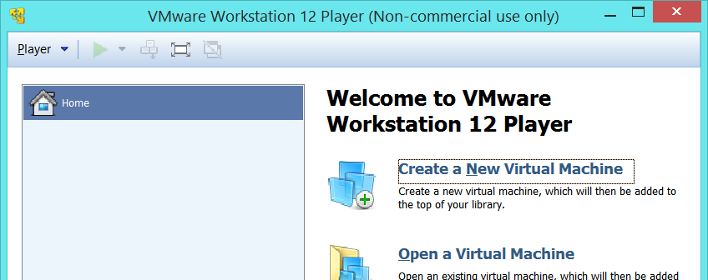

Select the Ubuntu 14.04.3 iso :

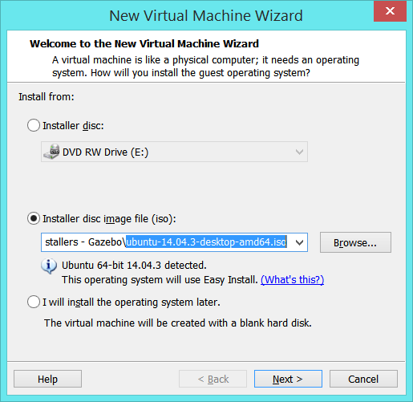

Enter the login « apm » and password « apm » :

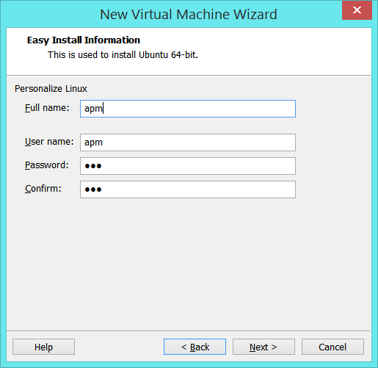

Name the machine « SITL » and place in « C:\px4\Virtual Machines\SITL »:

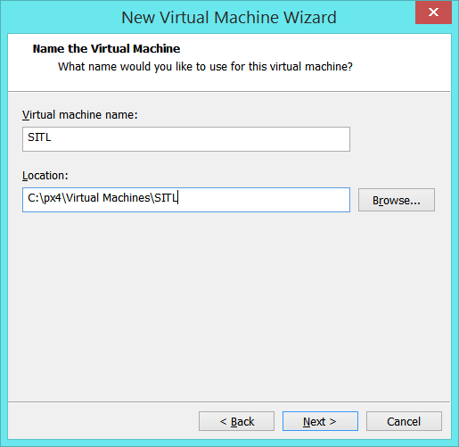

Give her 30.0 Gb and make sure to active « Split virtual disk into multiple files » :

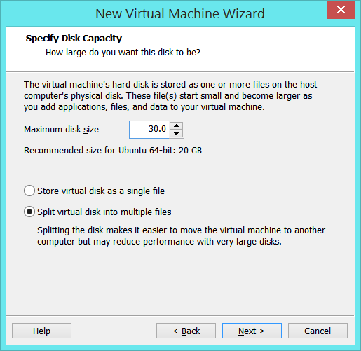

On the summary page, click on « Customize Hardware… » :

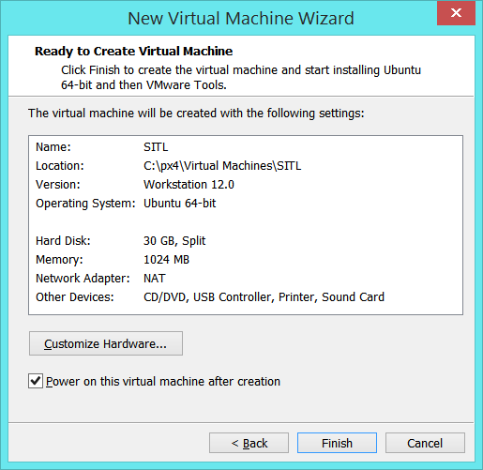

Allocate it 3072 MB (3GB) of memory:

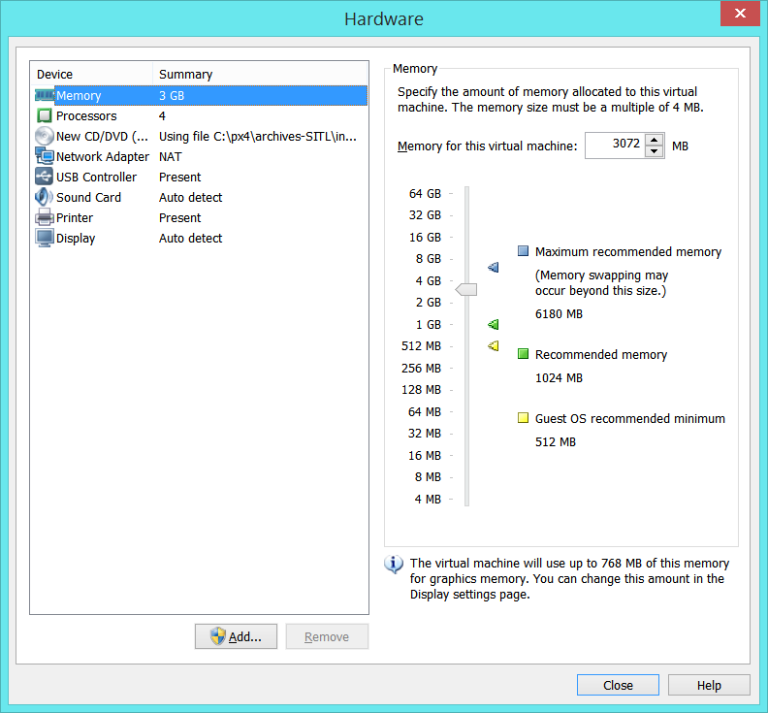

Define 4 processors:

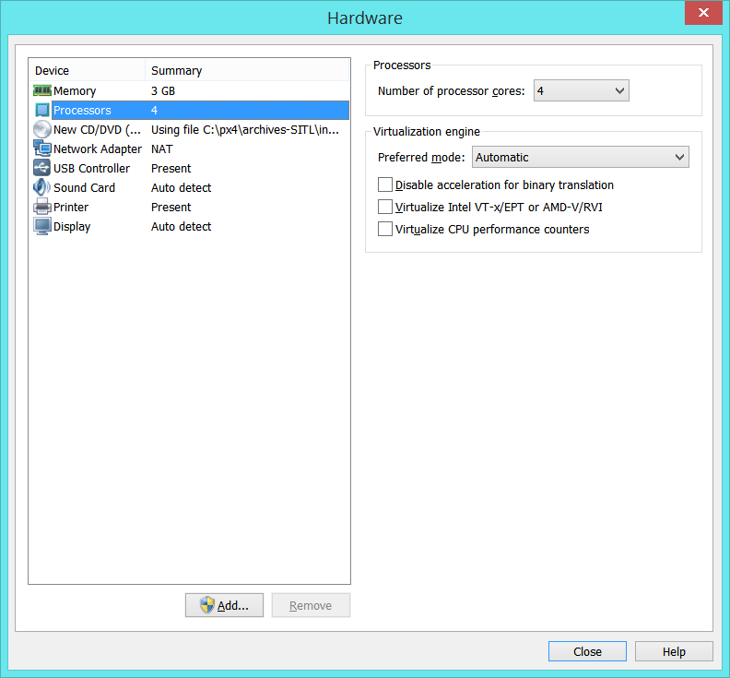

Leave the Network Adapter on NAT.

Accept the *Hardware* window, and click on *Finish* to complete the creation of the virtual machine.

### 1st launch of Ubuntu

By default VMWare starts Ubuntu right after the creation of the VM.

Ubuntu starts to installs itself:

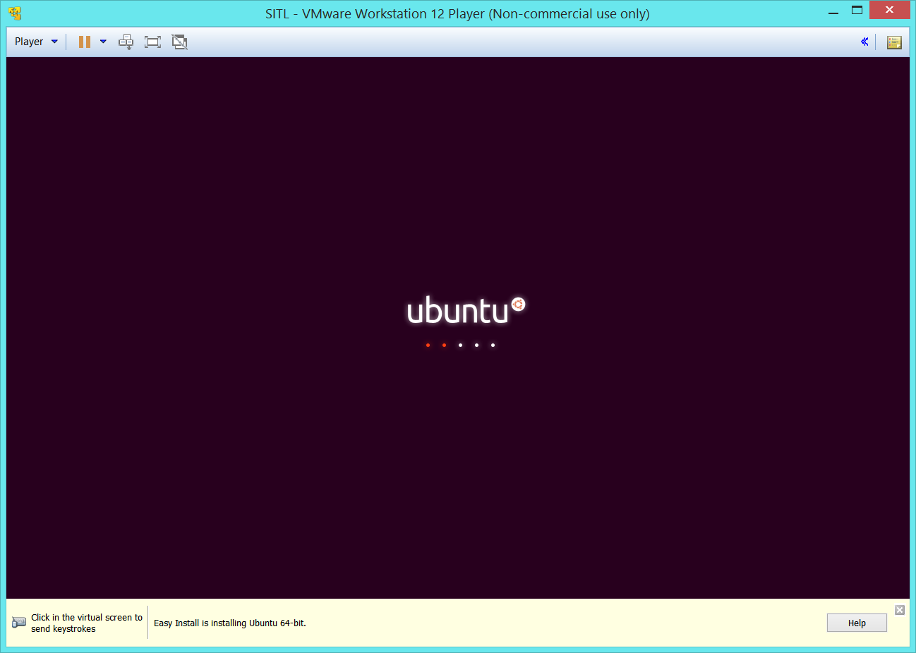 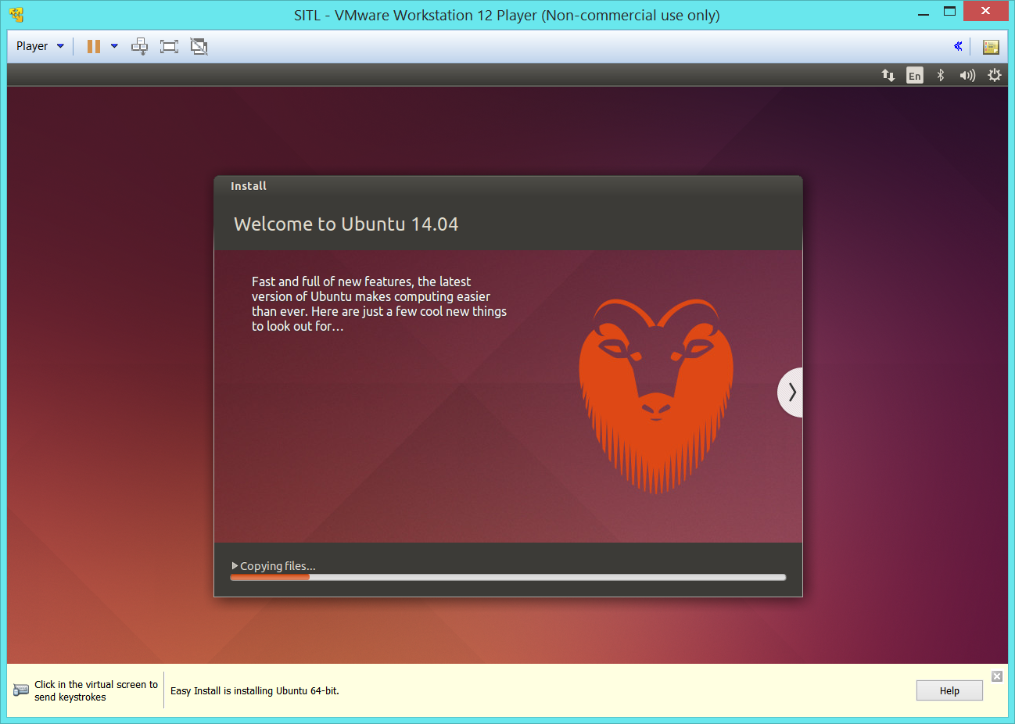

|  |
| --- |
| *Note :*  The hard drive load may jump to 100% during the installation, or on the login page after each startup of Ubuntu. Avoid launching cumbersome processes at the same time. |

Log on Ubuntu (password « apm »):

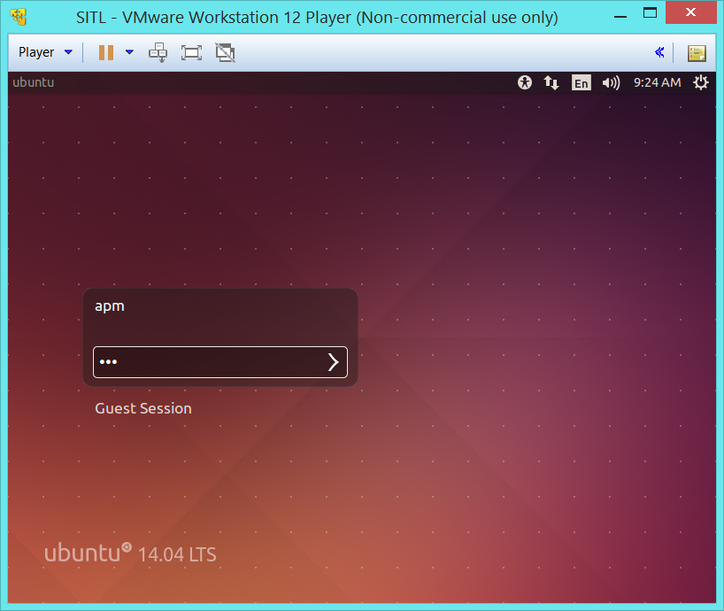 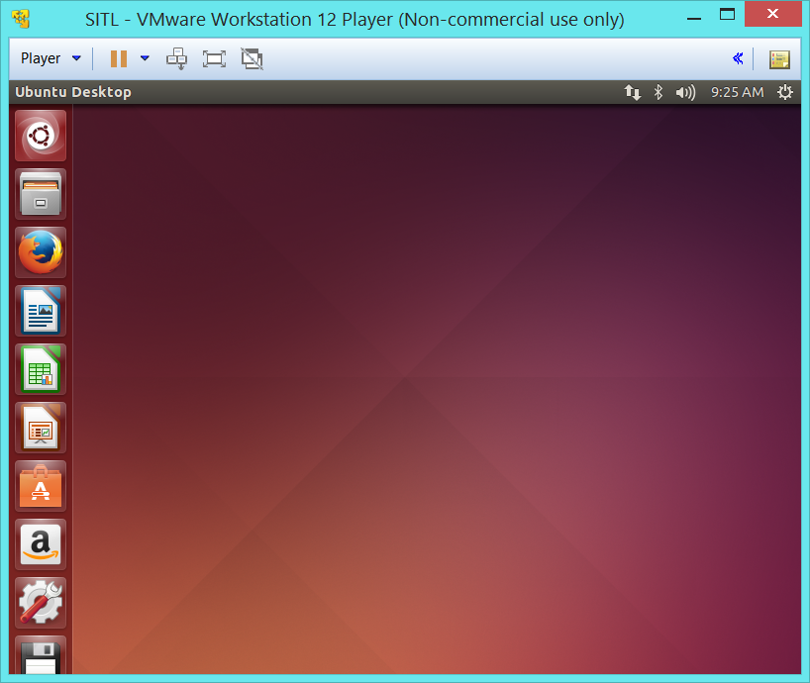

|  |
| --- |
| *Note :*  VMWare may propose to connect your camera or other devices to Ubuntu. Refuse (unless you need them, like later on for the joystick). |

|  |
| --- |
| *Note :*  Some errors may occur on VMWare, e.g. “Mouse thread did not respond to grab request”, or “Could not connect to X”, etc., and even sometimes result in a fatal crash.    Do not despair, just click OK, and if required re-launch VMWare and the virtual machine. |

Click on the Ubuntu logo on the top left corner, and type « terminal » in the type box that appeared to search for the software. Then drag and drop terminal icon in the taskbar to create a shortcut:

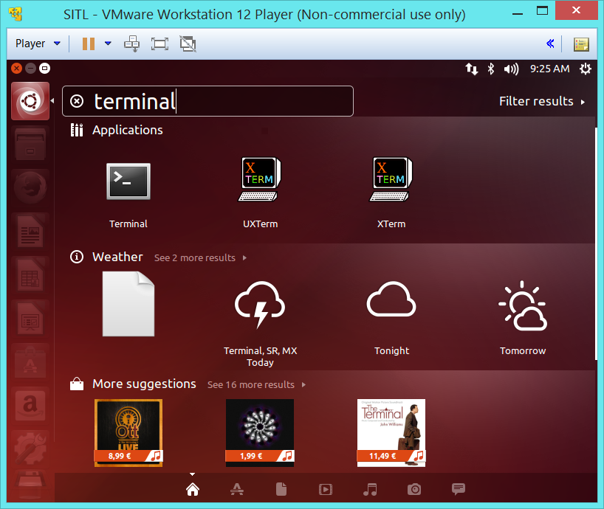 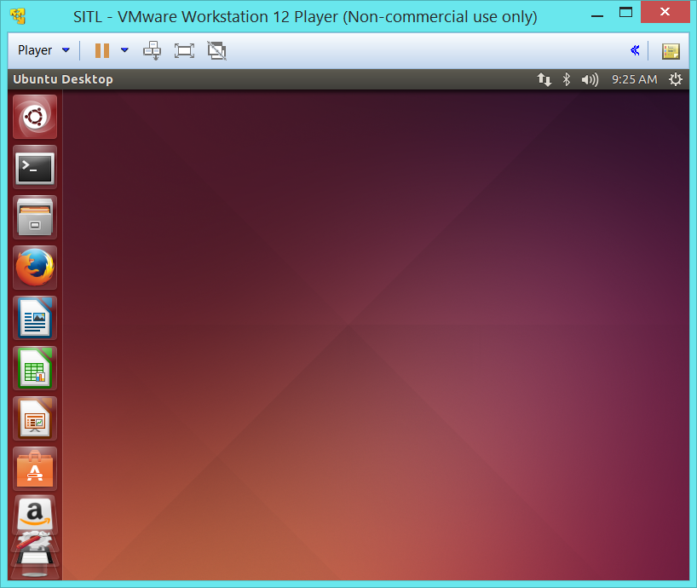

Update the time and time zone on the top right corner.

The following shell scripts are required to setup the environment:

* *step_1_configure_ubuntu.sh*
* *step_2_create_shared_folder.sh*
* *step_3_install_arducopter.sh*
* *step_4_install_ros.sh*
* *step_5_create_ros_workspace.sh*

To retrieve them, type in a terminal window the commands (from any directory, e.g. ~/Documents):

git clone https://github.com/AurelienRoy/ardupilot_sitl_ros_tutorial.git

chmod +x ./*.sh

It will authorize the execution of shell scripts.

|  |
| --- |
| *For the users who see Linux for the first time:*  The user directory is « /home/<user name>”, and in our case “/home/apm”.  It can be shortened with the “~” character, e.g. “~/Documents” is identical to “/home/apm/Documents”. |

Then in the same terminal, type in :

./step_1_configure_ubuntu.sh

It will take 10 to 15 minutes.

#### Setup of shared folders

Shut down Ubuntu (cog icon on the top right corner) :

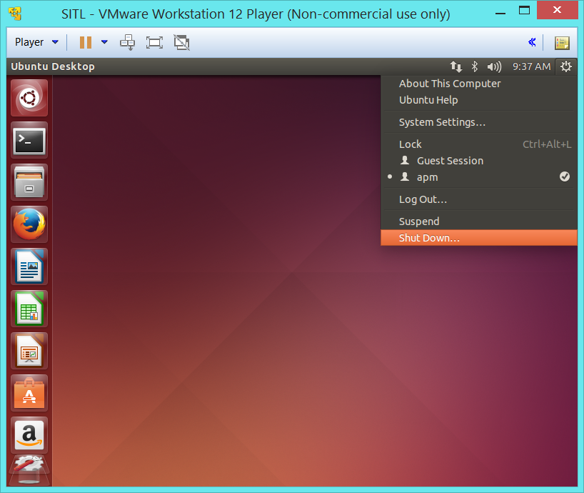

If it closed VMWare, restart it.

Click on « Edit virtual machine settings »:

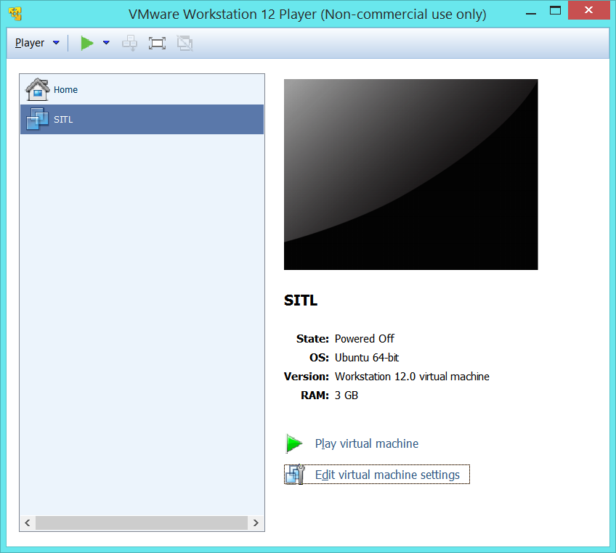

In the settings window, go to Options / Shared Folders, activate « Always enabled », and then add a new folder to share:

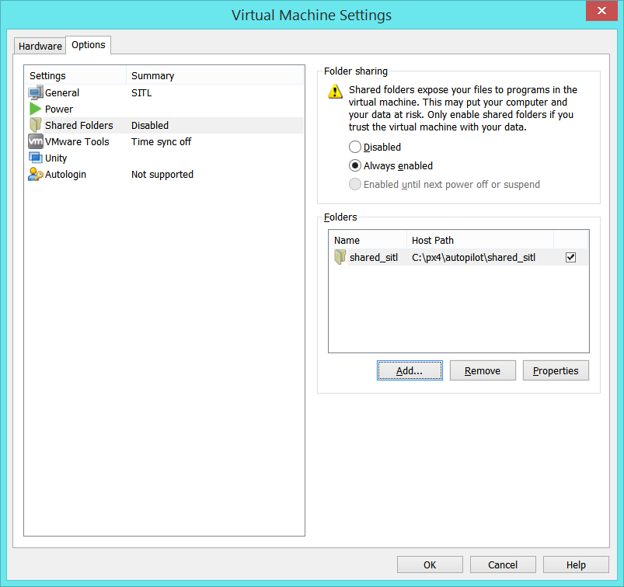

Select a folder that contains the ardupilot github project.

In my case, the ardupilot project was placed in *c:/px4/autopilot/shared_sitl/ardupilot*.

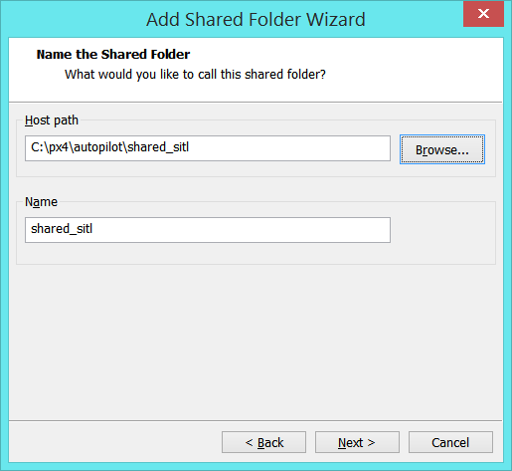

Click on *Next*

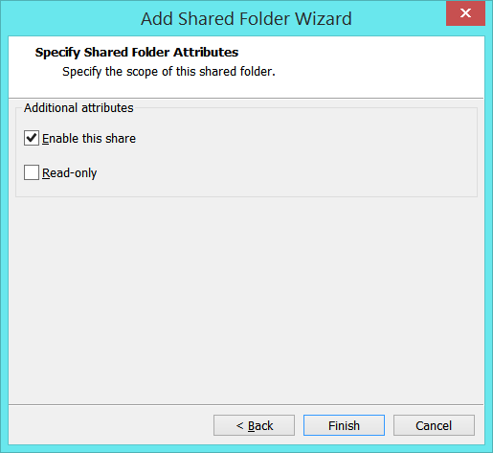

Restart the Virtual Machine (« Play »).

Log on the Ubuntu session.

Mount the CD with VMWare tools, through the menu bar: Player / Manage / ReInstall VMWare Tools

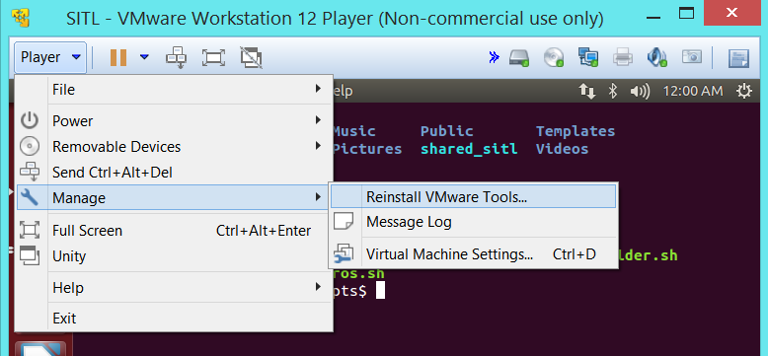

Usually Ubuntu opens up the CD directory. It is not useful, so you may close it:

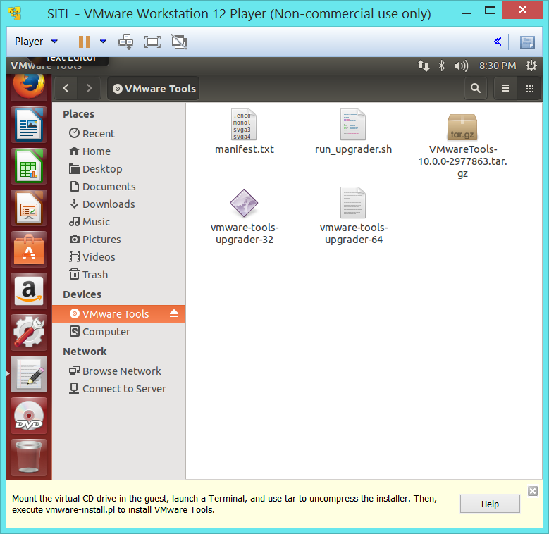

Open a new terminal and type in:

cd ~/Documents

./step_2_create_shared_folder.sh

Accept all questions (paths, …) by pressing *Enter*.

|  |
| --- |
| *Tip :*  If you press *Enter* multiple times you can accept in advance the oncoming questions. |

If the CD was not automatically unmounted, it is possible to do it manually on the menu bar:

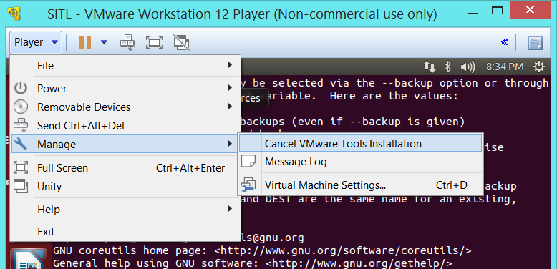

The shared folder should now appear in */home/apm*.

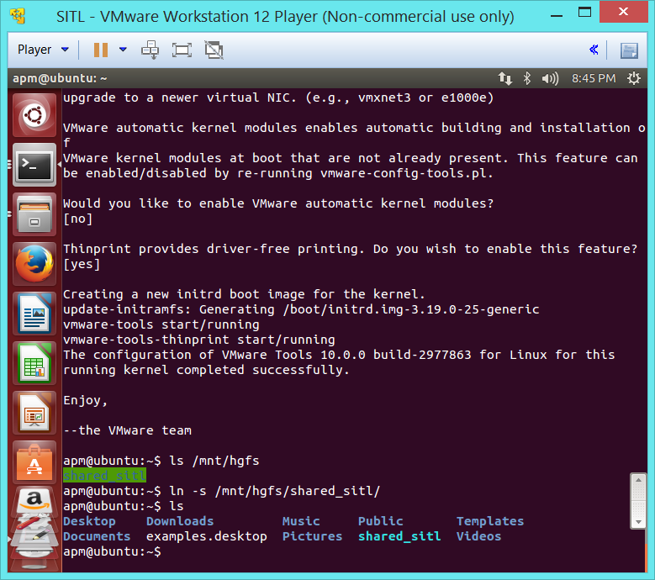

Congratulations!

From now any file / folder placed in shared_sitl on Windows will be accessible from Ubuntu, and vice versa.

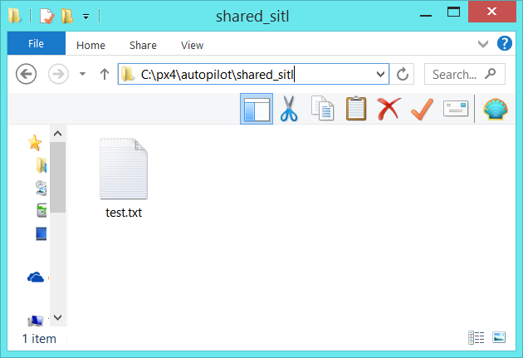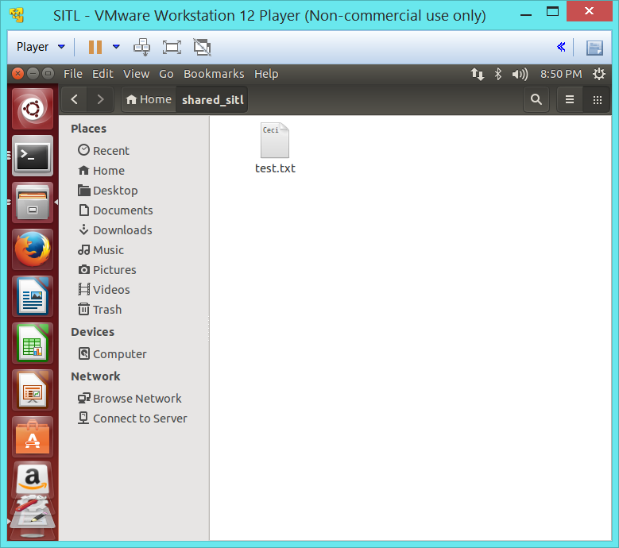

## Setting up the simulation

For the readers with a native Ubuntu installation who jumped directly to this section, you need to retrieve the following shell scripts:

* *step_3_install_arducopter.sh*
* *step_4_install_ros.sh*
* *step_5_create_ros_workspace.sh*

For this purpose, type in a terminal window the commands:

git clone https://github.com/AurelienRoy/ardupilot_sitl_ros_tutorial.git

chmod +x ./*.sh

It will authorize the execution of shell scripts.

### Installation of Ardupilot

|  |
| --- |
| *Note :*  If your shared folder is not called *shared_sitl*, then you shall change the path name written in the script *step_3_install_arducopter.sh*. |

Start the script *step_3_install_arducopter.sh*:

cd ~/Documents

./step_3_install_arducopter.sh

This shell script downloads Alex Buyval’s version of Ardupilot, and the latest version of JSBSim, and places them in */home/apm/shared_sitl*.

|  |
| --- |
| *Note :*  Once the github branch of Alex Buyval will be integrated in Ardupilot’s trunk, you will be able to switch the github project path in the script *step_3_install_arducopter.sh*. |

Afterwards, log off and back on the Ubuntu session to apply the changes to the PATH variable.

### Start the normal SITL

It is advised to run at least once the regular SITL, to make sure everything is properly setup up to this point.

On a terminal, from any directory (e.g. */home/apm*), type in:

./sim_vehicle.sh –v ArduCopter –j 2 –console --map

|  |
| --- |
| *Note :*  Thanks to the PATH variable, the system is able to find the *sim_vehicle.sh* script from anywhere. |

|  |
| --- |
| *Note :*  Sometimes not launching *sim_vehicle.sh* with the « -v ArduCopter » result in a connection error, “system sleeping”. |

It should open up a Mavproxy window and an APM console.

|  |
| --- |
| *Note :*  For more information on the regular SITL, and to make the UAV take off, go to :  <http://dev.ardupilot.com/wiki/setting-up-sitl-on-linux/> |

### Installation of ROS

Execute the shell script *step_4_install_ros.sh* by typing:

cd ~/Documents

./step_4_install_ros.sh

It takes 10 to 15 minutes.

Afterwards, start the script *step_5_create_ros_workspace.sh*:

cd ~/Documents

./step_5_create_ros_workspace.sh

## Launch a Gazebo simulation

Now call the Ardupilot simulation launch script:

cd ~/shared_sitl/ardupilot

sim_vehicle.sh –v ArduCopter -f arducopter_sitl_ros --console

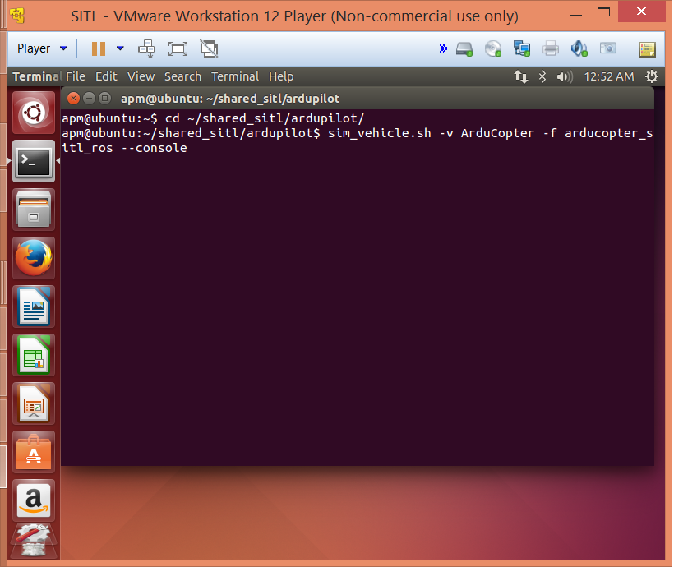

|  |
| --- |
| *Note :*  Without the argument « -v ArduCopter », the system throws back a connection refused error, process sleeping. |

|  |
| --- |
| *Note :*  The work of Alex Buyval has not yet been reintegrated on the trunk, so make sure to call the *sim_vehicle.sh* modified by Alex (from his github). |

|  |
| --- |
| *Tip :*  Gazebo takes some time to load the 3D display, and meanwhile just presents a black screen. You can already check that it loaded the models successfully by checking the world tree : |

If everything works, it should open up Gazebo.

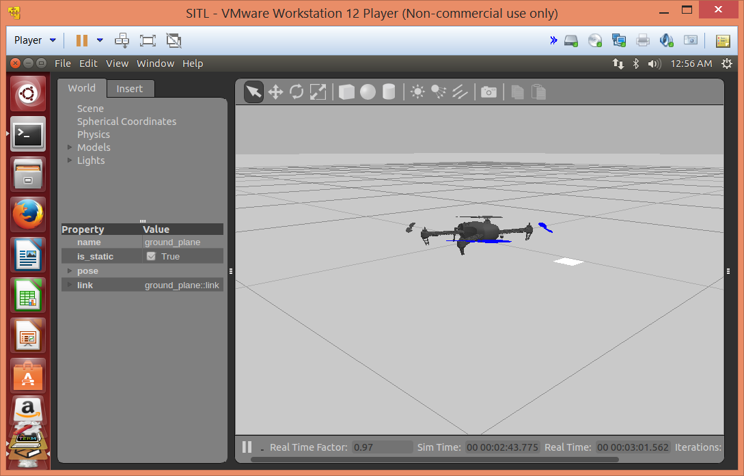

## Install a Joystick

Check that Windows recognizes the plugged in Joystick.

Then in VMware, assign the joystick to the virtual machine (it will disappear from Windows):

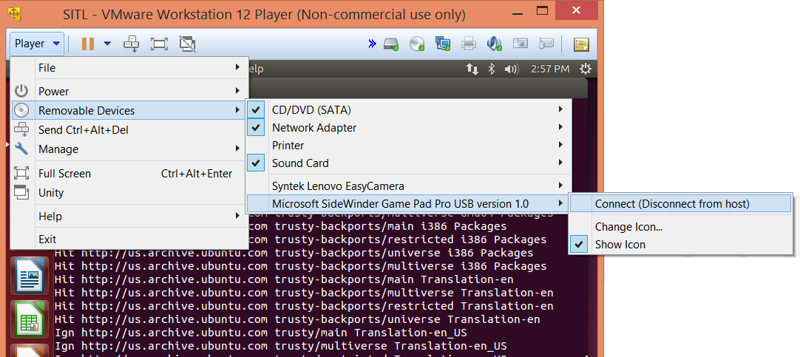

To configure the joystick on Ubuntu, you can follow the answers on:

<http://askubuntu.com/questions/32031/how-do-i-configure-a-joystick-or-gamepad>

<https://pixhawk.org/dev/ros/sitl#joystick_configuration>

Go to the directory:

cd ~/ros/catkin_ws/src/mavros/mavros_extras/launch

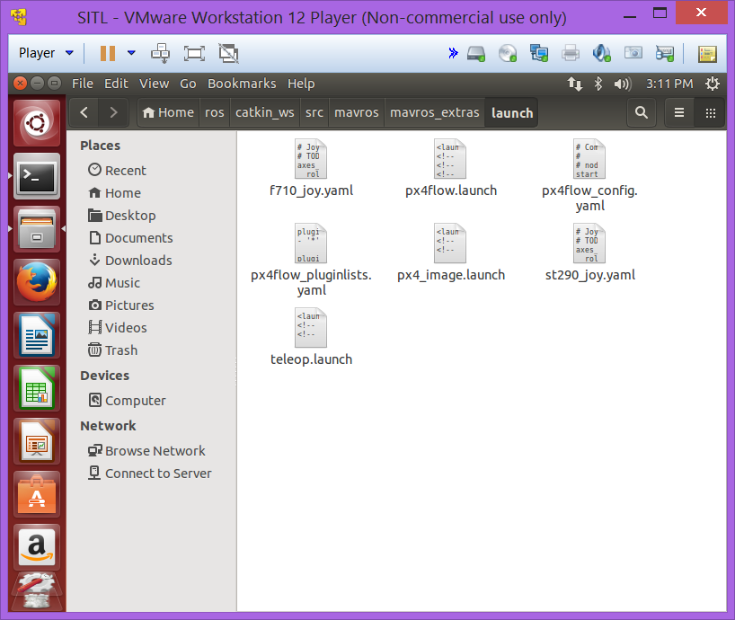

Create a *.yaml* file for your joystick model, on the example of « st290_joy.yaml » or « f710_joy.yaml ».

Then open up *teleop.launch* to call your new *.yaml* file.